Checklist
To confirm planning for indoor activity can start

Now that lockdown measures are easing in areas of the UK, some indoor guiding can take place.
If you are planning an activity with girls indoors you must:
- Complete this checklist. You can only meet indoors if you can answer yes to every question.
- Complete the risk assessment template.
- Make sure your checklist and risk assessment template are approved by your local commissioner before any meetings take place.
- Talk with your local commissioner if you have any questions.

 |  | Yes* | Guidance to help you complete this checklist and the risk assessment
1. | Has Girlguiding HQ said that face to face guiding is allowed in your area? | Y | You can find details on the Girlguiding website.  Regular communications are sent to leaders too.
2. | Have you checked how many people can meet, in line with government guidelines? | Y | Be aware that guidance on this might vary from area to area and change regularly. Girlguiding works with the government and youth sector organisations to update information.  Write in your risk assessment what you believe the restrictions are in your local area.
3. | Have you planned your activity to meet these guidelines, including social distancing in the space you have available in line with government guidance | Y | In your risk assessment, make specific notes about how you’ll manage the drop-off and collection parts of your meetings to include social distancing requirements.  Also, write how you’ll manage social distancing requirements. For example you might use hoops, markings on the ground, chairs, carpet mats or tables.
4. | Is there a suitable and accessible space that has been risk-assessed with Covid -19 responsible guidelines, that you can use for meeting? | Y | You should obtain a copy of the Covid-19 risk assessment for the  facility you are using. You may be asked to provide this before or  after getting your risk assessment signed off.  If you are moving to a new or temporary location then you must make sure GO is updated to show this.  You need to give details in your risk assessment about the safe area at the venue that you will use as a waiting area, if someone develops symptoms during the meeting.  And you’ll need to include your risk assessment details of any special conditions, like one-way systems; areas that can’t be used and maximum venue capacities.  Venues are encouraged to continue displaying a QR code for all attendees over 16 years old to scan using the appropriate Covid-19 app. This is good practice and it is recommended that you reinforce this.
5. | Have you discussed your cleaning responsibilities with your team? | NA | If you have cleaning responsibilities, how have you planned these with your team? And how is the responsibility shared between you and the venue? Document this in your risk assessment.
6. | Are enough adults available to run the activity safely and within ratio? You must have at least two for Rainbows, Brownies and Guides. Two are recommended for Rangers.  Also think about whether any volunteers won’t be able to attend due to Covid-19 symptoms, shielding, work or carer responsibilities. | ?? | Write the membership numbers of your team in the box below. Don’t include details of volunteers who can’t participate for personal reasons.  If you can only give two membership numbers then also include details  of your backup plan if a leader is unavailable. Your backup plan could include parent helpers, but you still need one disclosure-checked volunteer.  You must make sure parent helpers are fully informed, and you must share your risk assessment with them. Write in your risk assessment if parent helpers will be attending and whether you have given them all the right information.  Your backup plan might be to cancel or meet online as this may be the only or safest option.
7. | Will there be someone at your meeting who has completed A Safe Space Level 3 training? | ?? | Give the membership number of the person(s) who has this training (there’s a box for this information at the end of the checklist).  You must not hold a meeting if the leader that holds A Safe Space Level 3 training is unavailable.
8. | Do leaders have up-to-date disclosure (DBS/PVG/Access NI) checks?  Take into account the extensions on  re-checks that were granted due to lockdown. | ?? | Confirm this in the box at the end of the checklist. If you’re not sure, check with your commissioner.
9. | Will first aid be available if needed?  This should be provided either by the venue or activity provider, or by qualified Girlguiding volunteers. | ?? | You need to give information about the person(s) who has this training.  Do this in the box at the end of the checklist.
10. | Is the first aid kit available, in date and stocked with appropriate personal protective equipment? This includes gloves and masks. | ?? | Write who is responsible for providing the first aid kit for your meeting. Also give details in your risk assessment of extra personal protective equipment that you will have available.  And you may need to consider changes to your procedures if you have members with medical needs.  You can find guidance on some extra equipment that should be added to your first aid kit in the FAQ section of the Girlguiding website coronavirus updates – it’s in the Face to face meeting dropdown section.
11. | Are all members’ details up to date on GO? | ?? | Make sure this applies to all your leaders and girls, and then give the date that this was confirmed in the box at the end of the checklist.
12. | If you are using an external provider, have you checked that they are following appropriate social distancing and hygiene measures, in line with government guidance?  If you aren’t using an external provider please write N/A in the box. | NA | An external provider is an organisation, company or individual who is not affiliated with Girlguiding that make activities available.  Is there anything specific you need to mention?
13. | Have you planned how you’ll manage Covid-19 related risks within your risk assessment? | ?? | Be clear about what actions you will be taking to manage Covid-19. So, whenever the risk assessment has words like consider, should or such as (for example), write specifically what you and your team plan to change and put in place.  Covid-19 is a serious disease, so the severity column of your risk assessment should only be high.  What you need to think about is the likelihood of something happening. And what you are aiming to do is document in the risk assessment what steps you and your leadership team plan to take to reduce the likelihood of this happening as much as you can. So if something might nearly always happen if you did nothing, you should be able to change this to either often happens or rarely happens, once you have taken your planned action.

Use this box to give the information requested from the checklist above
Name of Unit:

Membership numbers of your team.  Highlight Y to confirm if they have an up-to-date disclosure check. | 1. | Y/N | 3. | Y/N
 | 2. | Y/N | 4. | Y/N
Give details of your back up plan here.

Membership number of volunteer with
A Safe Space Level 3.
Who is your first aid being provided by? Please highlight the appropriate one. | Qualified Girlguiding volunteer
If Girlguiding volunteer please give membership number.

If venue/activity provider or other, please give further details.
Date that you checked all members’ details are up-to-date on GO.
Checklist signed by Commissioner:

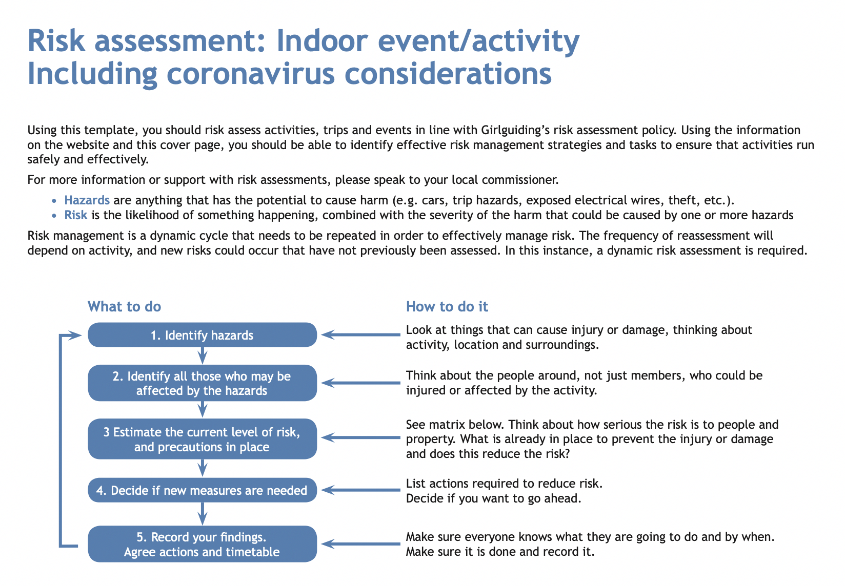
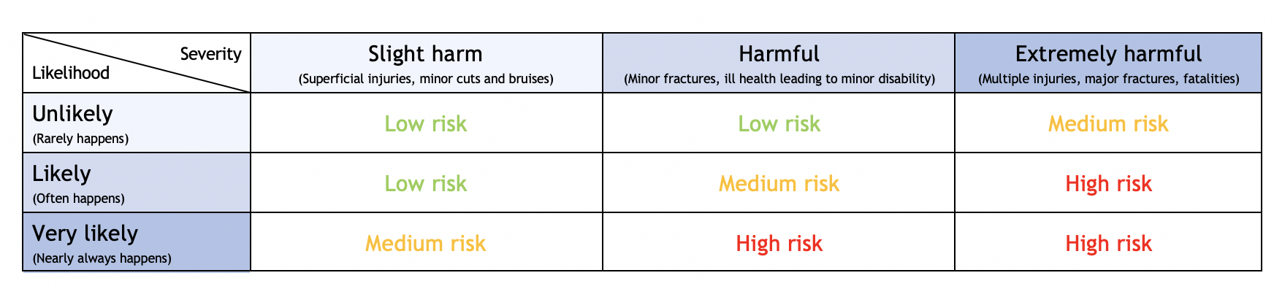
Event information and risk assessment approval:

Name of Unit:

Event/activity (brief description) Theatre trip to see Southend Gang Show |  |  |  | Date:
Leader in charge: | Total attending: | Adults : | Girls/young women: |  | General public: at venue but not part of our party
Consent for activity/event forms completed please state: |  |  |  | Venue: Palace Theatre Westcliff
Instructor qualification checked* please state: / N/A

Decision: once all the actions are carried out, can you eliminate or safely manage the risk of harm to ensure you can safely go ahead with this event/activity? If there is still some challenge or risk, are you still confident the control measures in place will keep girls safe? |  |  |  | Yes
If you answered no to the above decision question, please explain why:

Risk assessment completed by: |  |  |  | Role:
Has the risk assessment been shared with the leadership team?

Risk assessment must be reviewed weekly and ongoing with every change to either the meeting plans or government guidance on coronavirus safety measure. |  |  |  | Date: If rules change prior to event or when we next visit this venue
¹Adults refers to adult volunteers who are part of the event/activity delivery team. * Refer to the activity finder for information about instructor qualifications.
Note to leaders: We recommend you agree with your approving commissioner/assessing team in advance how long they will need to review your risk assessment. We suggest allowing two weeks as a reasonable amount of time.

Hazards  What could cause harm or damage? | Who or what is at risk of being affected and how? | What are you  already doing?  How have you reduced the risk already? | Likelihoodof risk occurring (L/M/H) | Severity of risk  (L/M/H) | Are further controls necessary?  What else needs to happen to reduce the risk to an acceptable level? | Action by:  name/date  You must complete this for every action | Guidance notes  Be as specific as you can with the detail that you give in this document. What will you do to reduce the risk of a hazardous event happening?
You should use the examples below as a starting point for your risk assessment – delete those that are not appropriate and add those that are in order to take account of all the likely risks that might be present at your meeting. Covid guidance varies between nations and you will need to adjust your risks in line with government guidance. You can find further information on this page.
Photos or videos being taken of the meeting without permission. | Risk to privacy of members. | Brownies are not allowed to have phones. Leaders know one Brownie who does not have photo consent. Leaders will also be aware of other units taking photos to ensure she is not in background. | L | L |  | Leaders on day of event | Remind yourself of digital safeguarding policy.  Make sure that others are also clear about the photography and video rules.
Volunteers posing  a risk. | Risk to wellbeing of young members. | ?? leaders have DBS. ?? has SS3 and ?? valid FR.  ?? leader has LQ and ?? is working towards. | L | L |  | No actual action needed. | Remind yourself of the recruitment and vetting policy and procedure.
Personal information of volunteer or young members being given out. | Risk to privacy of members. | Event set up by unit leaders, using BCC if via email. | L | L |  | ?? or other leaders if needed | Remind yourself of the managing information policy and procedure.
Coronavirus infection risks (see below).  These must be reduced to an acceptable level. | All attendees are at risk from spread of virus through close contact. | Actions are in rows below | M | High |  | As in following rows | Make a dynamic risk assessment at the start of every meeting to identify all hazards and move them or take them into account.
Infection risk from parents. | Crowding at the start and end of a meeting creates a risk of virus transfer. | Given the venue it will be difficult to avoid crowding. However, current government rules require adults to wear masks, and this will be adhered to by guiding units and members of public should also be wearing face coverings.  In all communications to parents and carers clearly state that no girl must attend if she or anyone in the household is showing symptoms of Covid-19. | M | High | We will encourage parents to drop girls and leave as quickly as possible. | ?? to ensure parents aware prior to event and leaders to be vigilant on day of event. | Give clear and precise plans to demonstrate that it is possible to carry out drop off and pick up safely and within social distancing rules.
Close contact between people. |  | We will ensure ratios will be maintained. There will be ?? adults with our group.  Should anyone show symptoms leader will take her out to foyer (or outside near door if crowded) until she is collected. This should not be a safeguarding issue as others will be around. For rest of unit, other girlguiding adults can assist remaining leaders if needed.  We do not have any members who need adjustments related to COVID | M | High | Venue will be increasing fresh-air ventilation throughout the building wherever possible.  Rules on face coverings will be followed by all members of Girlguiding and should be followed by general public (although we have no control over this). | Leaders on day of event | Check venue requirements regarding face coverings and follow them.  Parent helpers may be needed to maintain ratios. Put this in the risk assessment and make sure they are fully aware of expectations during this time, including the guidance around face covering, social distancing and the risk of self-isolating if someone tests positive.
Close contact between young members and leaders or adult volunteers. |  | Add masks and gloves to the first aid kit, to be worn when administering first aid. | M | High |  | ?? to ensure First Aid kit and leaders on day of event if needed.
Sharing equipment. |  | There will be no ‘equipment’. Venue say “We’ll be cleaning all areas more frequently and thoroughly, including wiping down surfaces throughout your visit“. | M | High |  | Action mainly by venue, but leaders to ensure girls sanitise on arrival and as needed.
Poor hand hygiene |  | Make sure everyone has clean hands when they arrive.  Have hand sanitizer available and encourage everyone to regularly reapply and always clean hands before and after any contact.  Encourage everyone to bring their own tissues and provide spare tissues. Ensure that all used tissues are thrown away into a bin or disposable rubbish bag, then hands are washed or sanitized. | M | High |  | ?? to bring hand sanitizer to use as needed. Will have black sack for rubbish.
Infection of vulnerable members. |  | We have no girls or volunteers who have a medical condition which makes them especially vulnerable at this time. | M | High |  | No actions unless new information received about vulnerability. | Detail management actions to mitigate any risks for vulnerable members and volunteers here.
Poor respiratory hygiene. |  | Reinforce the ‘catch it, bin it, kill it’ message.  Venue will be increasing fresh-air ventilation throughout the building wherever possible. | M | High | Bring spare tissues, sanitizer and rubbish bags with you in case the venue runs out or does not provide them. | ?? to bring hand sanitizer to use as needed. Will have black sack for rubbish.
Poor level of cleanliness of hall and equipment, especially after other hirers. | Potential for cross-contamination and passing infection between users. | Venue say “We’ll be cleaning all areas more frequently and thoroughly, including wiping down surfaces throughout your visit“.. | M | High |  | ?? to bring wipes in case needed. | Include details of who is responsible for cleaning and when it will be done.
Someone falling ill with Covid-19 symptoms during meeting. | Potential for cross-contamination and passing infection between users. | Should anyone show symptoms leader will take her out to foyer (or outside near door if foyer is crowded) until she is collected. This should not be a safeguarding issue as others will be around. For rest of unit, other adults from district will assist remaining leader if needed.  Inform venue. | M | High |  | Leaders on day of event. | Detail the extra personal protective equipment that you have available here.  If you are meeting at a property that you own or manage have you reviewed the checklist and risk assessment? Visit the website for more information and guidance on managing property during coronavirus.
Participant displays symptoms after meeting, raising concerns that others may have been infected. |  | We have made sure parents have given the most up-to-date contact and health details, and that GO is updated accordingly.  Attendance records will be kept for one year after any meeting as required by Girlguiding and in case test and trace is required due to a later suspected case. | M | High |  | ?? on day/  afterwards | Are all volunteers aware of the potential impact of self-isolation, as well as the potential for testing positive themselves?
Please use the sections below to capture the other hazards and controls at your activity, as you normally would.
Girls getting ‘lost’ | All young people because they are in an unfamiliar environment | Unit will keep together. If a need to separate at least one leader will be with each group – never with a leader one to one with a girl. Girls will always be in at least pairs. Girls will be given clear direction about where to meet their leader if necessary. | M | H |  | Constant awareness by all volunteers on day
Members of General Public | Potential safeguarding risk. | No girl is to wander off alone. Discuss need to stay as a group. | L | L |  | Constant awareness by all volunteers on day
Allergies | All attendees | No attendees have any declared allergies. | L | L |  | No actions needed
Slips trips falls collisions with other attendees | All attendees | Girls to be reminded to walk not run and to be calm when moving around the venue. They will be reminded that there are steps and it may be dark when we enter. Extra care if moving around during the performance. | L | M | Remind girls of this before entering the venue | Constant awareness by all volunteers on day
Unforeseen emergency requiring evacuation of the venue | All attendees | Girls to be reminded that if this occurs to remain with the leaders of our group. Leaders will follow usual practices for making sure we have all girls with us.  Directions of venue staff will be followed.  Home contact is in place  We will gather outside at an appropriate distance from venue and immediately take a register. | L | H |  | All leaders to complete actions on day if needed
Toilets | Young members | If using toilets as a group at least one adult (with DBS) will wait inside.  If one girl using toilets alone, leader will check if others are using toilets. If yes, she will wait inside toilets, if no, she will wait outside. During performance one leader may take one girl as this is very public and would not pose a safeguarding issue. | L | L |  | Leaders on day of event
Adjustments for different needs | All attendees | Add any needs here or state if none | L | L |  | All leaders on day of event.
Buying of sweets/ice creams | All attendees | Girls will not be permitted to leave auditorium to buy sweets etc, but may be permitted to buy ice cream from vendors inside. No allergies. Girls will be supervised if they do this. | L | L |  | All leaders on day of event.
Personal possessions | All participants | Girls encouraged to bring minimum of personal belongings. These should be in a bag which closes so they cannot fall out. | M | L: |  | MG to advise parents prior to event.
Signed by commissioner: |  |  |  | Date:

